**Geological Description of the Study Site and IODP Expeditions**

Fig. 1 shows a map of expeditions and holes related to IODP Expeditions 349, 354, 355, 356, 359, 361 and 362.

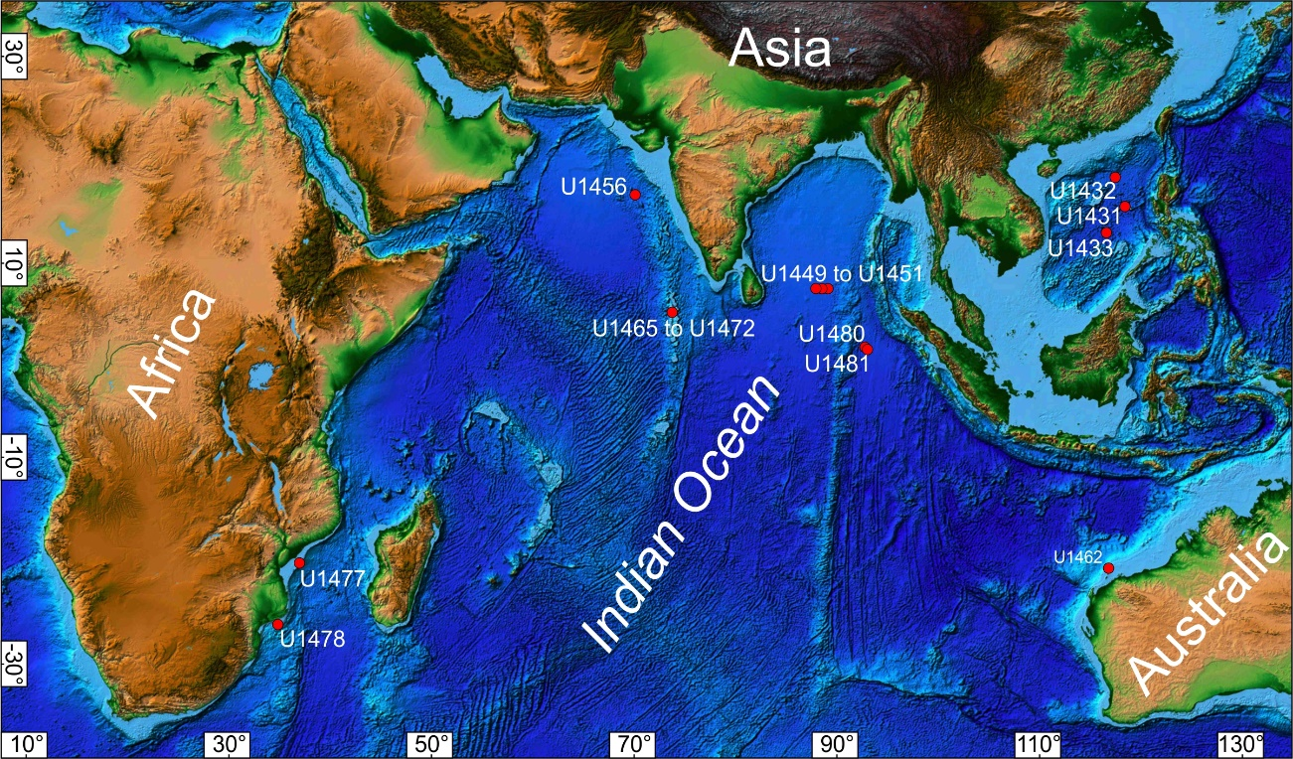

Figure 1 Map of expeditions sites for this study. Sites U1431, U1432 and U1433 – IODP Expedition 349 (Li et al., 2015); Sites U1449, U1450 and U1451 – IODP Expedition 354 (France-Lanord et al., 2016); Site U1456 – IODP Expedition 355 (Pandey et al., 2016); Site U1462 – IODP Expedition 356 (Gallagher et al., 2017); Sites U1477 and U1478 – IODP Expedition 361 (Hall et al., 2017); Sites U1480 and U1481 – IODP Expedition 362 (McNeill et al., 2017); Sites U1465, U1466, U1467, U1468, U1470, U1471 and U1472 – IODP Expedition 359 (Betzler et al., 2017). Map modified from ETOPO1 Global Relief Model (Amante and Eakins, 2009).

IODP Expedition 362, which occurred from August 6 to October 6, 2016, carried out the drilling of two sites U1480 and U1481, whose main problems to be answered are the establishment of the initial and evolving properties of the Sumatran incoming sedimentary section and the potential effect of these properties on seismogenesis, tsunamigenesis, and forearc development for comparison with global examples (Mcneill et al., 2017). It is highlighted in this expedition as objectives the determination of the lithology, sedimentation rates, physical, chemical and thermal properties of each entry section.

Sediments and sedimentary rocks were recovered from a depth of 1415.35m in nine holes U1480 (A-H) and U1481 (A) (Mcneill et al., 2017). The unconsolidated sediments and sedimentary, tuff layers and basic rocks formed between present and Cretaceous Late. The global succession of the holes represents two sections, the pre-Nicobar Fan and Nicobar Fan ones. The pre-Nicobar Fan succession comprises Creataceous Late to Eocene volcanic and siliciclastic-carbonate rocks accumulating between the Sunda subduction zone and the Ninetyeast Ridge. Overlying this pre-Nicobar Fans succession, occur Miocene to early Pleistocene siliciclastic sediments deposited from various gravity flows, derived from Nicobar Fan, with some cm- to mm-thick ash layers. From Pleistocene to recent pelagic sediments with interlayered ash layers covered the drilled sections.

IODP Expedition 354 occurred from January 29 to March 31, 2015, where drilling of seven sites was carried out, 320km long transect across the Bengal Fan. These drillings give a spatial view of the water and sediment deposit of the system comprising the Bengal Fan. The sediments collected in this expedition come from the Himalayan Rivers, generated from terrestrial changes, erosions and weathering of the Himalayas and are transported through a delta and shelf canyon, providing large turbidity currents loaded with a wide spectrum of grain size (France-Lanord et al., 2016).

IODP Expedition 355 drilled two sites (U1456 and U1457) in Laxmi Basin in the eastern Arabian Sea to document the evolution of mountain construction, weathering, erosion and climate over a range of timescales. The Indian summer monsoon is one of the most intense climatic phenomena on the planet, being linked to the growth of topography in south and central Asia. The expedition collected samples from a depth of 1109.40m below the seabed. In these drillings, the sediments were dated from 13.50 to 17.70 million years (Site U1456) and ranging from 10.90 to 62.00 million years (site U1457). Site U1457 is more distal in facies, reflecting its more marginal setting. No major active lobe appears to have affected Laxmi Basin since late Pleistocene (Pandey et al., 2016).

IODP Expedition 359 performed at the Indian Ocean, Maldives Archipelago, from September 30 to November 30, 2015, seeking to study sea level changes and their currents along with the evolution of the Indian Ocean Monsoon. Seven sites (U1465, U1466, U1467, U1468, U1470, U1471 and U1472) were drilled to provide unread records of the evolving ocean Cenozoic icehouse world. The main objective of this expedition has been to date precisely the onset of the current system (Betzler et al., 2017).

IODP Expedition 349 drilled five sites in the South China Sea basin (SCS), seeking to deepen basin formation studies and understand east Asian tectonic evolution, 1524.00m of sediments/sedimentary rocks, 78.00m of oceanic basalt were recovered and geophysical information was collected from the wells mainly in places with higher depth (Li et al., 2015).

IODP Expedition 356 traversed the northwest of Australia, searching for precise information on the Indonesian Throughflow (ITF) and all the climatic evolution that has been linked to the Australian monsoons and their variability over time. It should be noted that the expedition sought to identify nature and development of the entire sedimentary structure on the Australian Continent (Gallagher et al., 2017).

IODP Expedition 361 drilled six sites on the southeast African margin, totaling 5175.00m of recovered rocks. The sites are located between the Mozambique channel and the Natal Valley, influenced by the discharge of hydrographic materials from the rivers, resulting in an environment with high potential for temporal studies and with the capacity to identify the complete formation of south-east Africa (Hall et al., 2017).

**References**

Amante, C., Eakins, B. W., 2009. ETOPO1 Global Relief Model converted to PanMap layer format. NOAA-National Geophysical Data Center, PANGAEA, https://doi.org/10.1594/PANGAEA.769615.

Betzler, C. et al., 2017. Expedition 359 summary. Proceedings of the International Ocean Discovery Program (359), https://doi.org/10.14379/iodp.proc.359.101.2017.

France-Lanord, C. et al., 2016. Expedition 354 summary. Proceedings of the International Ocean Discovery Program (354). https://doi.org/10.14379/iodp.proc.354.101.2016.

Gallagher, S.J. et al., 2017. Expedition 356 summary. Proceedings of the International Ocean Discovery Program (356), https://doi.org/10.14379/iodp.proc.356.101.2017.

Hall, I.R. et al., 2017. Expedition 361 summary. Proceedings of the International Ocean Discovery Program (361), https://doi.org/10.14379/iodp.proc.361.101.2017.

Li, C.-F. et al., 2015. Expedition 349 summary. Proceedings of the International Ocean Discovery Program (349), https://doi.org/10.14379/iodp.proc.349.101.2015.

Mcneill, L. C. et al., 2017. Expedition 362 summary. Proceedings of the International Ocean Discovery Program (362). https://doi.org/10.14379/iodp.proc.362.101.2017.

Pandey, D. K. et al., 2016. Expedition 355 summary. Proceedings of the International Ocean Discovery Program (355), https://doi.org/10.14379/iodp.proc.355.101.2016.